Compiler Design-Lex programs

1.Write a LEX specification file to take input C program from a .c file and count tthe number of characters, number of lines & number of words.

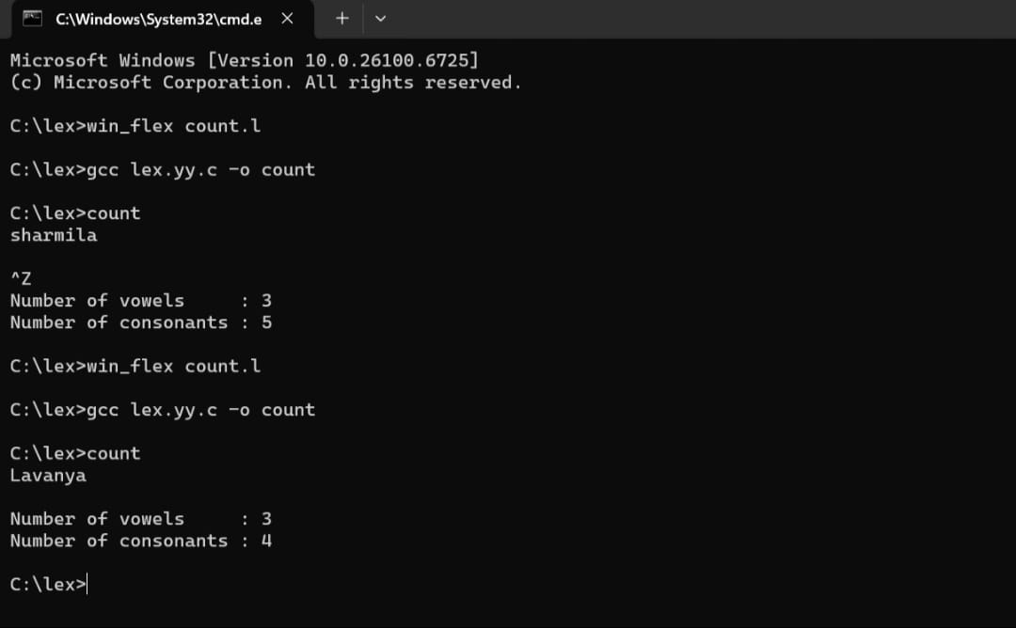

2.Write a LEX program to print all the constants in the given C source program file.

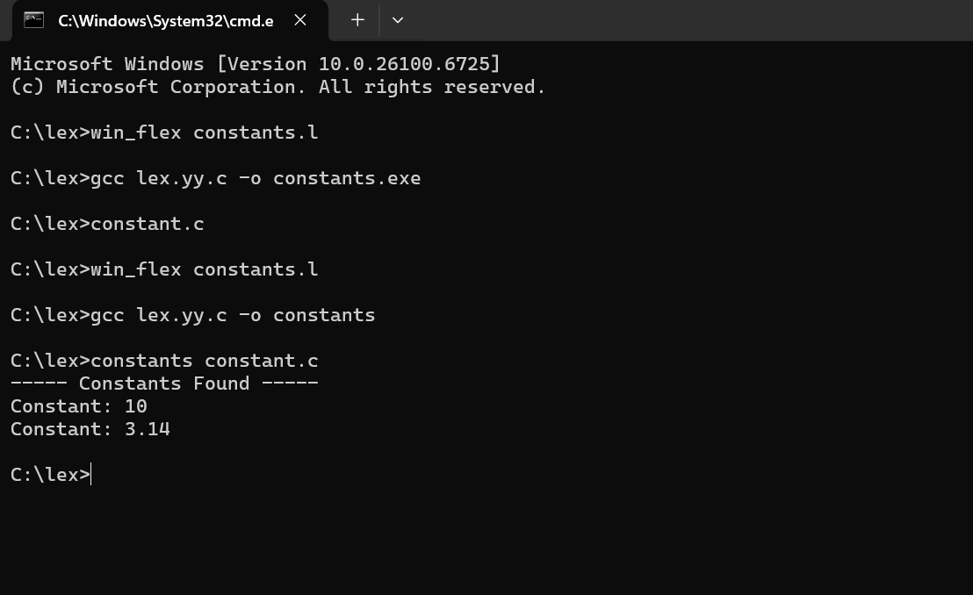

3.Write a LEX program to count the number of Macros defined and header files included in the C program.

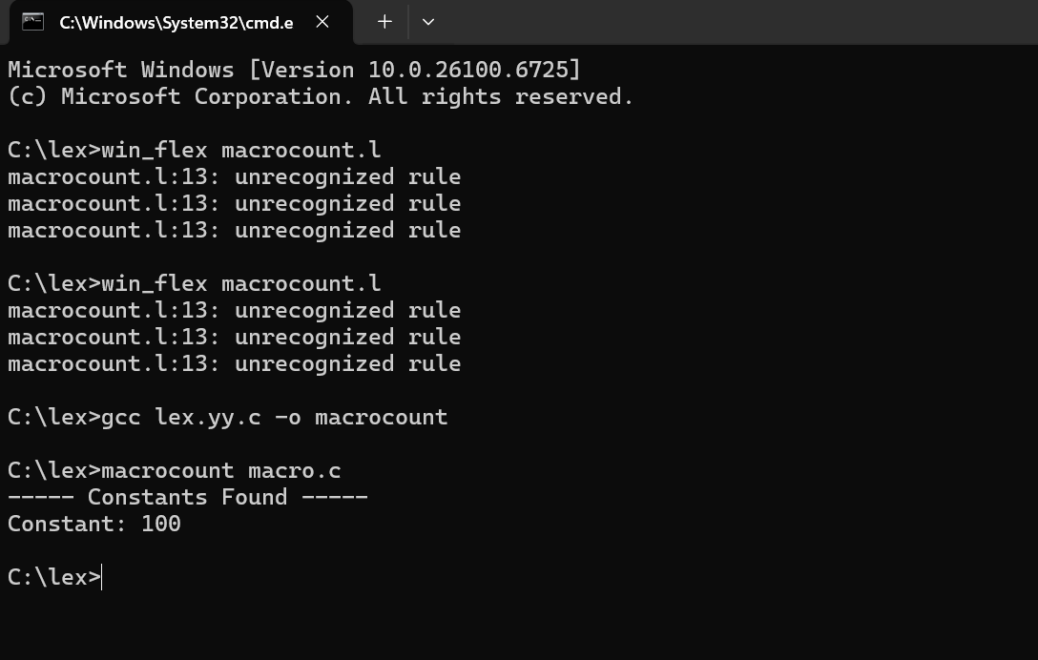

- Write a LEX program to implement basic mathematical operations.

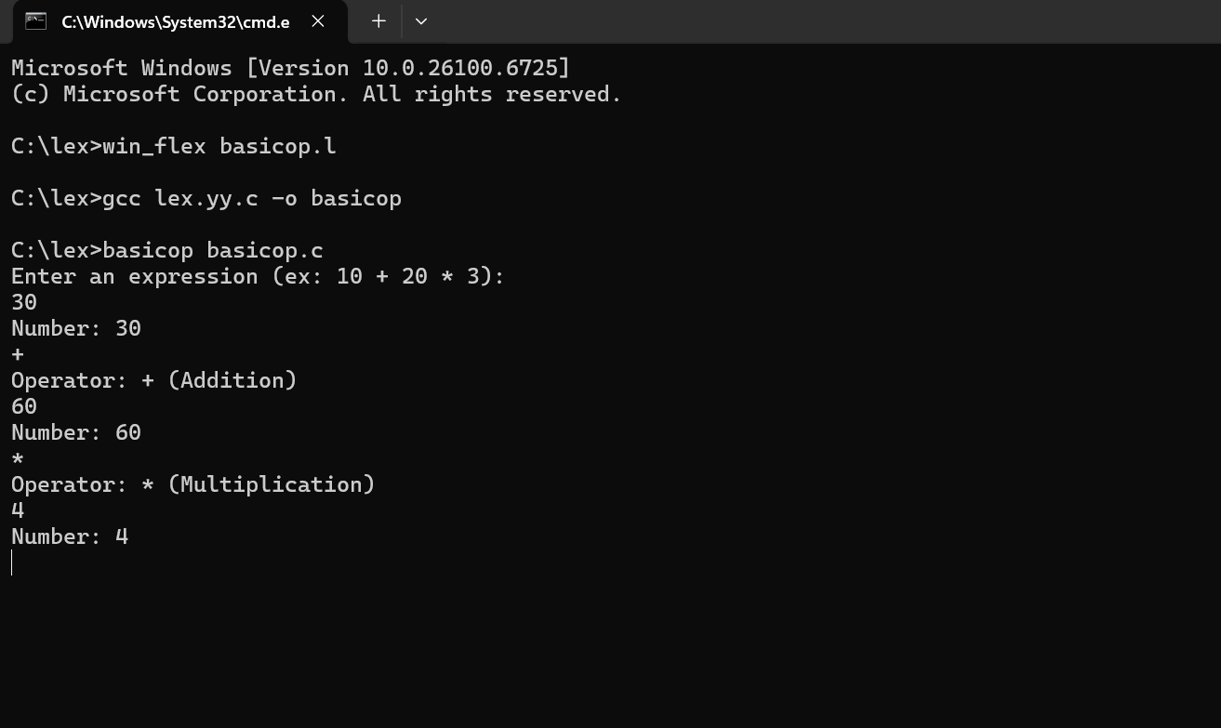

5. Write a LEX program to check whether the given input is digit or not.
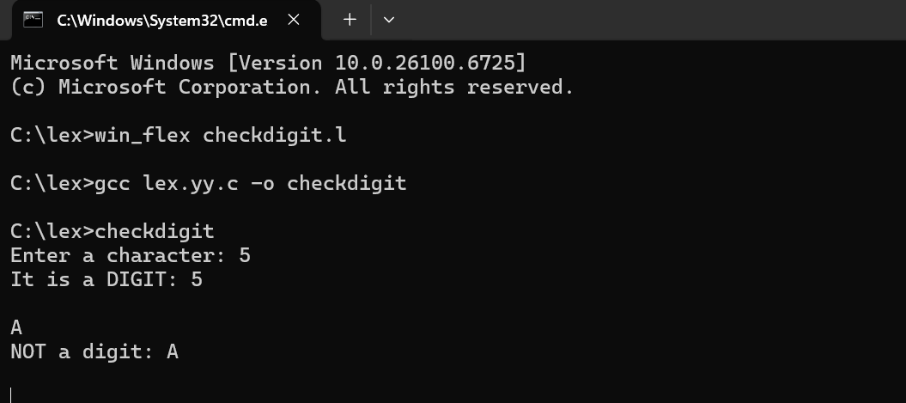

6.Write a LEX program to validate DOB of students.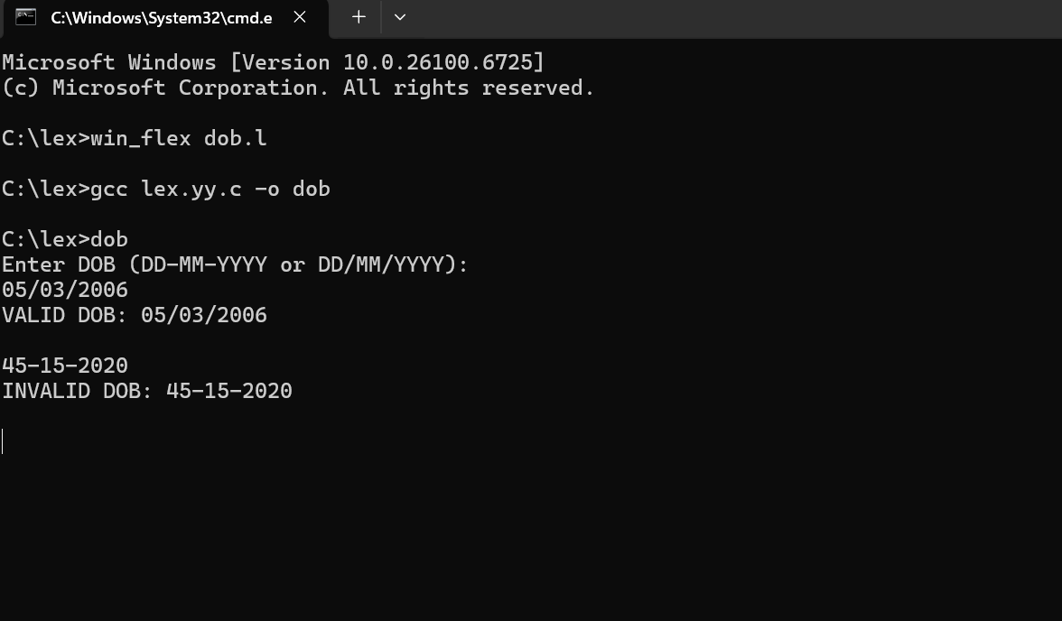

7. Write a LEX program to identify and count positive and negative numbers.
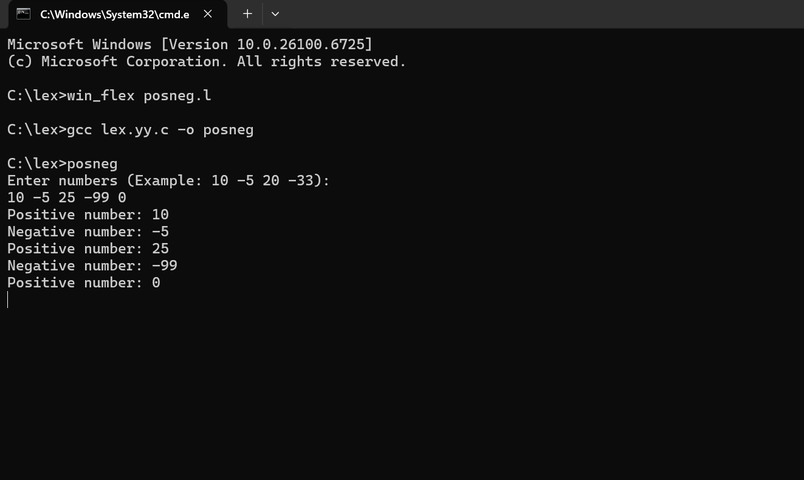

8. Write a LEX program to separate the keywords and identifiers.

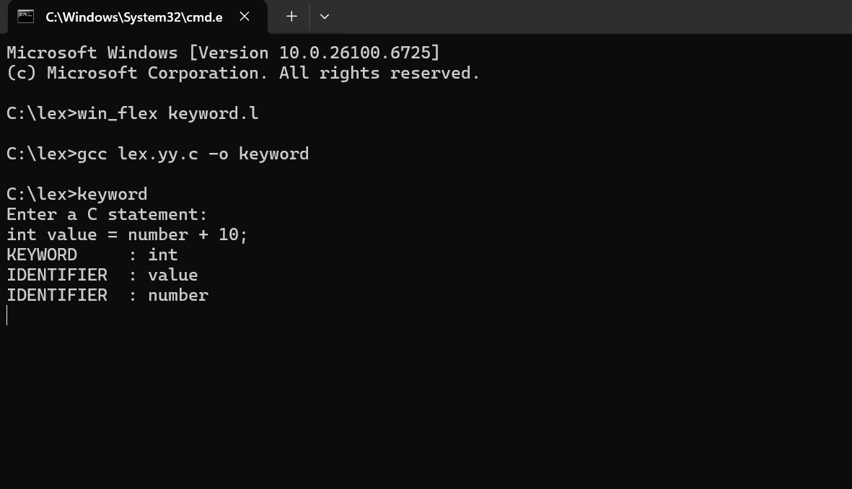

9.

